Purpose / Scope:
Entry point of the PLM2 implementation program at KTX Toccoa: change management, SEP / project planning, data management, lessons learned and information security move into one controlled, web-based system. In an audit this overview is shown first; the stream document of the topic is pulled next to the live system.
Owner / involved:
- C. Demmler, Process Development: owner of PLM2 and of every action in this plan, author, keeps it current
- Program Management and APQP: support (specification, tests, pilots on the running projects, evidence)
- Departments named per action (IT, Quality, Development, Tooling, HR, department heads): support where their part is needed
- Plant Management: monthly status review
1. Program at a glance
Document | Stream | State today | PLM2 only from
TOC-PLM-01 | Change management (ECR) | Built. In test; role model being tightened | 12/21/2026
TOC-PLM-02 | SEP / project database | Built. Evidence being uploaded; 1994 is lead project | 01/18/2027 (new projects)
TOC-PLM-03 | Data management, traceability | Core tight; remaining functions in development | 03/22/2027
TOC-PLM-04 | Lessons learned | Built. Being bound into SEP and ECR | 01/04/2027
TOC-PLM-05 | Information security (TISAX) | Built on company SSO and server; three points tightening | 12/11/2026

2. From today to target
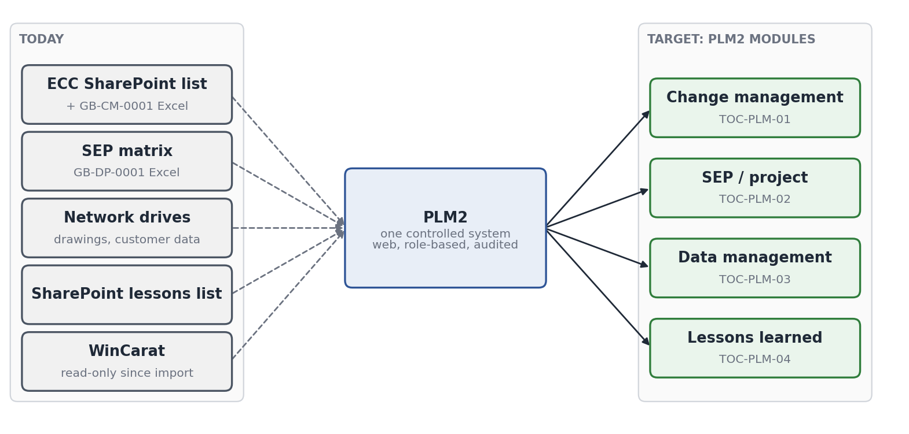
Where we come from (brief). The information is correct today, but it lives in several places: SharePoint lists, Excel forms (GB-CM-0001, GB-DP-0001), network drives and a read-only legacy system. Not everyone can reach every source, and the link between a customer change, the part level, the tool and the gauge is kept by hand. The program closes exactly these points:
Today | Target with PLM2
Several tools, no single controlled record | One system of record per topic; old sources frozen read-only at go-live
Access depends on site and SharePoint rights | Web access for every department with the company account, rights by role
Traceability maintained by hand | Part-tool-gauge-equipment relations and revision history are system data, with where-used and audit trail
Timing in separate files, tasks by e-mail | Gate dates, change plans and deadlines in the record; every person sees their own tasks with due dates

3. Master timing
Each stream runs through programming (close the remaining functions), testing (scripted acceptance test and live pilot on real projects) and finalisation (procedure released, training, old source frozen). Operation and the effectiveness review follow.
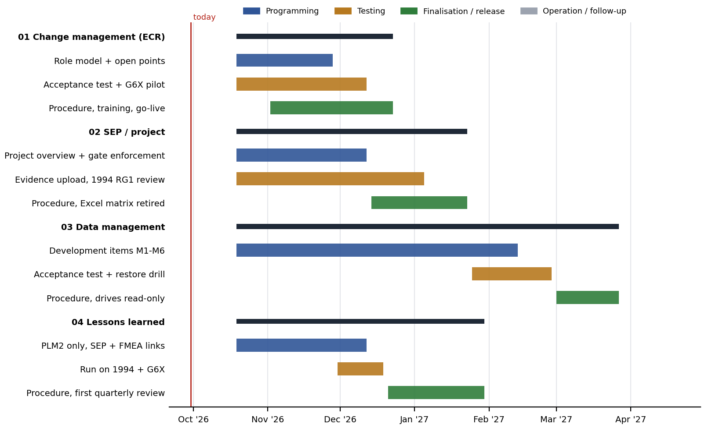
Milestone | Meaning
12/11/2026 | ECR acceptance test and G6X pilot complete; SEP gate enforcement live; TISAX points closed
12/21/2026 | ECR go-live: every new change at TOC runs in PLM2 only; the SharePoint ECC list becomes read-only
01/04/2027 | Lessons learned procedure released; SEP evidence of running projects uploaded
01/18/2027 | SEP go-live: new projects start in PLM2 only; the Excel SEP matrix is retired for new projects
03/22/2027 | Data management go-live: network drives read-only for active projects
03/2027 | Effectiveness reviews per stream, reported to management review

4. Using this in an audit
If the auditor asks about | Pull | Show live in PLM2
Control of changes (IATF 8.5.6, 8.3.6) | TOC-PLM-01 | A change record: stages, hard gates, routing, timing plan, sign-offs, audit trail; G6X changes CR-2026-0001..0003
Project planning, APQP, gates (IATF 8.3.2, VDA MLA) | TOC-PLM-02 | Project 1994: SEP matrix RG1-RG7, items, evidence, dual sign-off
Engineering specs, document control, traceability (IATF 7.5.3, 8.5.2) | TOC-PLM-03 | Part with revision history, where-used, tool and gauge relations
Organisational knowledge (IATF 7.1.6, 10.3) | TOC-PLM-04 | Lessons board: G6X lessons with actions and effectiveness proof
Information security, prototype data (TISAX, VDA ISA) | TOC-PLM-05 | Company sign-in, roles, classification, audit trail
Status of all of the above | TOC-PLM-LOP (KTX LOP F-DVS-CORP-010) | Open actions with owner, due date and status

Rule until each go-live: the existing controlled forms stay valid and are filed on the PLM2 record, so control never has a gap. Where both exist, the PLM2 record leads.
5. How we implement: completed examples
PLM2 follows the same method that already brought two systems into daily controlled use at KTX Toccoa. Both run on the same company server, behind the same company sign-in, and are the record for their process today.
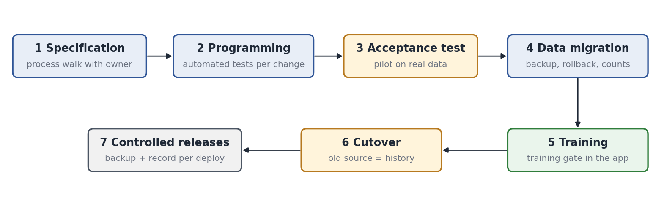
 | TWOS (tooling work orders) | RFQ2 (quotation system)
Process controlled | Tool work orders, press calls, repairs, preventive maintenance, tool handover, spare parts | RFQ costing: BOM, tooling cost, clamping force, cycle time, tool layout and machine choice, quote
Replaced | PowerApps apps on SharePoint lists | Excel / PowerPoint quoting without revision control
Users | 19 users in 6 roles (toolshop, scheduling, process technicians, managers) | Sales, engineering departments, APQP, project management
Live | On server 07/04/2026; system of record from 08/05/2026 (plant cutover) | System of record from 06/30/2026
Data migrated | 1,230 work orders, 230 tools, 1,270 history rows, 76 spare parts | Running RFQs; awarded RFQs frozen (e.g. RFQ 26 on 09/21/2026)
Tests | About 775 automated backend tests | About 1,880 automated backend tests
Training | Classroom sessions plus training gate with sign-off records | Per department at introduction
Cutover control | Backup before cutover, written rollback, SharePoint kept as history only | Backup before every release; local-to-server data push disabled
Link to PLM2 | Tool data read by PDB; preventive maintenance status from WinCarat | Machine picks of RFQ 25 / 26 taken over into PLM2 tools (09/29/2026)

6. Program control
- Monthly status review with Plant Management against this timing and the LOP; minutes filed in PLM2.
- A date moves only with a reason recorded in the LOP; the stream document is updated to the new status.
- Each stream closes with an effectiveness review (indicators in the stream document) reported to management review.
- Software quality: every release passes the automated test suite (about 2,000 backend and 2,900 frontend tests) before it reaches the production server; the database is backed up before every data operation.

